

Interior Finishes

Fixture & Finish Schedule
By Janet Holland
Ground Level

Paint Schedule
ROOM | SURFACE | NAME & CODE | PAINT TYPE/FINISH | SAMPLE
All rooms | Ceiling | High Reflective White  SW 7757 | Sherwin Williams  Flat | 
Entry, Living Room, Dining Room, Kitchen, Mudroom, Hall around stairs, North, East, South, West | Walls | High Reflective White  SW 7757 | Sherwin Williams  Satin
Kitchen Cabinets, Mudroom Storage Cabinet, WC Vanity, Laundry Cabinets | Cabinets | High Reflective White  SW 7757 | Sherwin Williams  Semi-Gloss
All rooms | Crown Molding, Trim Casing Windows, Trim Baseboard, Internal Doors | Extra White  SW 7006 | Sherwin Williams  Semi-Gloss | 
Laundry, North, East, South, West. base coat for wallpaper | Wall paint | Bonsai Tint  SW6436 | Sherwin Williams  Satin | 
Water Closet North, East, South, West. base coat for wallpaper | Wall paint | Aleutian  SW 6241 | Sherwin Williams  Satin | 
Entry Console Table | Console Table | Aleutian  SW 6241 | Sherwin Williams  Semi-Gloss
TV/Game/Study North, East, South, West. base coat for wallpaper | Wall paint | Distance  SW6243 | Sherwin Williams  Satin | 
External Front & Back Door | External Doors | Tricorn Black  SW 6258 | Sherwin Williams  Semi-Gloss | 
Paint Console Table for Front Entry | Paint Console Table | Sherwin Williams  Aleutian SW 6241 | Sherwin Williams  Semi-Gloss | 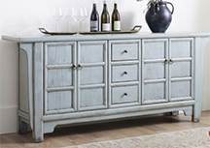
Laundry Room NESW Walls | Wallpaper | Watercolor Herringbone Wallpaper, Fir Color | Love vs Design | 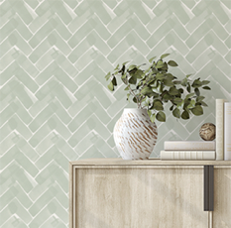
Water Closet NESW Walls | Wallpaper | Laura Ashley, Barley, Wallpaper roll by Graham & Brown, Dusky Seaspray Color | Wayfair | 
TV/Game/Study NESW Walls | Wallpaper | Twig Hygge Herringbone Wallpaper by York Wallcoverings  Navy & Gray Color | Wayfair | 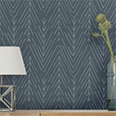

Trim & Molding Schedule
ROOM | SURFACE | DETAILS, PROFILE, SIZE | PRODUCT NAME | SAMPLE
Entire 1st floor | Crown Molding | SPP8012  PR48  D 9/16 x H 4 ¼" W  Sherwin Williams Extra White, SW 7006 | PMD  Pacific Mutual and Door  Crown Molding | 
Entire 1st floor | Baseboard | SPP8385  D 5/8 x 5 ¼” W  PR658  9/16 x 5 ¼” W  Sherwin Williams Extra White, SW 7006 | PMD  Pacific Mutual and Door Baseboard
Entire 1st floor | Casing Windows & Doors | SPP301  D 21/32 x 3 3/16” W  PR301  5/8 x 3 ¼” W  Sherwin Williams Extra White, SW 7006 | PMD  Pacific Mutual and Door  Casing Windows & Doors | 

Flooring Schedule
ROOM | SURFACE | DETAILS, PROFILE, SIZE | SUPPLIER | SAMPLE
All Main Level Floors | Rivers Edge White Oak Smooth Solid Hardwood | American Spirit  SKU: 100968304  Size ¾ Depth x 4” Planks | Floor & Décor | 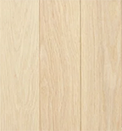

Kitchen Schedule
ROOM | SURFACE | DETAILS, PROFILE, SIZE | SUPPLIER | SAMPLE
Upper Cabinet Cupboards | Upper Cupboards | W 42” x H 51” x D 12” W  (42” W Each side of the Range)  (4 ¼” Crown Molding)  3 Wood Doors, 12” W  3 Glass Doors, 12” W  Sherwin Williams High Reflective White, Semi-Gloss  SW 7757 | Stanley Wood Products, Custom Build | 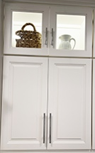
Upper Cabinet Finish Doors | 3 Shaker Style Doors, 3 Glass Doors Above | W 42” x H 51” x D 12”  (42” W Each side of the Range)  (4 ¼” Crown Molding)  3 Wood Doors, 12” W  3 Glass Doors, 12” W  Sherwin Williams High Reflective White, Semi-Gloss  SW 7757 | Stanley Wood Products, Custom Build
Custom Range Hood | Range Hood | 1 - W 38” x H 36” x D 22”  (4 ¼” Crown Molding)  Sherwin Williams High Reflective White, Semi-Gloss  SW 7757 | Stanley Wood Products, Custom Build | 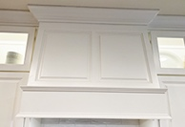
Lower Cabinet Finish | Lower Cabinet Drawers | W 42” x H 34.5” x D 24”  3 Drawer Stack Left Side of Range 24” W. And 1 - 18” Wide Storage Cabinet next to refrigerator.  Sherwin Williams High Reflective White, Semi-Gloss, SW 7757 | Stanley Wood Products, Custom Build | 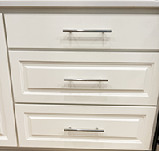
Lower Cabinet Finish Doors | Shaker Style Doors | W 42” x H 34.5” x D 24”  (42” W Each side of the Range)  3 Doors, 12” Wide Right Side of Range. And 1 – 6” W Filler Cabinet  Sherwin Williams High Reflective White, Semi-Gloss, SW 7757 | Stanley Wood Products, Custom Build | 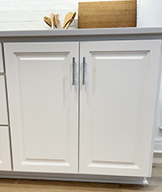
Above Refrigerator Cabinet Cupboard | Upper Cupboard above Refrigerator | W 40” x H 36” x 26” Storage Cupboard above Refrigerator,  Sherwin Williams High Reflective White, Semi-Gloss, SW 7757 | Stanley Wood Products, Custom Build | 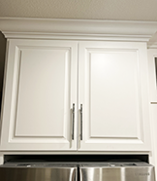
Above Refrigerator Cabinet Finish Doors | Shaker Style Doors above Refrigerator | W 40” x H 36” D 26” Storage Cupboard above Refrigerator, 2 Doors,  Sherwin Williams High Reflective White, Semi-Gloss, SW 7757 | Stanley Wood Products, Custom Build
Peninsula Lower Cabinet | Lower Peninsula Cabinets | W 11’ Total x H 34.5” x D 24”  Sherwin Williams High Reflective White, Semi-Gloss  SW 7757 | Stanley Wood Products, Custom Build  Example of Spice Cabinet W 12”, Recycle W 18”, Compactor W. 15”. (No drawer above Recycle) | 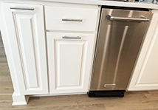
Peninsula Lower Cabinet Finish Doors | Shaker Style Doors | W 11’ Total x H 34.5 x D 24”  Sherwin Williams High Reflective White, Semi-Gloss  SW 7757 | Stanley Wood Products, Custom Build  Example of Sink Cabinet W 36” | 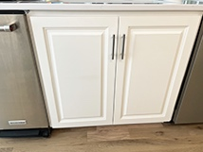
Peninsula Appliances Stainless Steel | Shaker Style Doors | W 11’ Total x H 34.5 x D 24”  Sherwin Williams High Reflective White, Semi-Gloss  SW 7757 | Stanley Wood Products, Custom Build  Example of Dishwasher W 24”, Microwave W 24” (Remove the stack to add the Microwave and add a W 24” filler storage cabinet below it) | 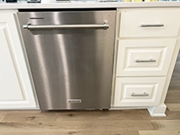
Peninsula Right End Panel and Back Side | Peninsula Right End Panel and Back Side Shaker Style | 1 - H 34.5 x D 24” End Panel  Sherwin Williams High Reflective White, Semi-Gloss  SW 7757 | Stanley Wood Products, Custom Build | 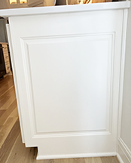
Roll-Out Shelves Lower Cabinets on Right side of the range | Roll-Out Shelves | 2 - W 24” x D 24”  Solid Wood Roll Out, Shelves at the mid-point and bottom  Sherwin Williams High Reflective White, Semi-Gloss,  SW 7757 on the Exterior. | Stanley Wood Products, Custom Build | 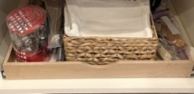
Peninsula Internal Pull-Out Spice Rack | Pull-Out Spice Rack | 1 - W 12” x D 24” Wood Pull-Out Spice Rack  Sherwin Williams High Reflective White, Semi-Gloss, Exterior Door  SW 7757 | Stanley Wood Products, Custom Build | 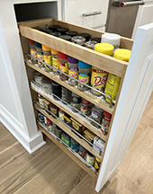
Concealed Soft Close Hinges | Kingsman Hardware | 64 - All Cabinets, Kingsman Hardware Concealed (35 mm) 110 Degree Clip-On Frameless Soft Close Full Overlay Cabinet Hinge 12 pairs (24 Pieces) Dimensions:  H 1” x W 2.5”, D 4.5”,  Model: WCH-A016-12 | Home Depot | 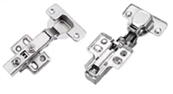
Quartz Countertop & Backsplash | Calacatta Borghini,  Elements Quartz | Calacatta Borghini,  Elements Quartz, Group 5  Countertop in Kitchen L 42” Each side of Range x 24” Deep  Range Backsplash from the Range to the Vent Hood & Base cabinets to Upper Cabinets.  Peninsula L 11’ x D 24” | Central Surfaces, MO | 
Kitchen Sink | Blanco Sink | 1 Blanco Precis Coal Black Granite Composite 32" Super Single Bowl Undermount Kitchen Sink  32 L x 19 W x 9.5 D - Minimum cabinet size 36”, White  Model# 440150 | Home Depot | 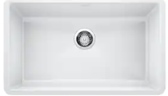
Garbage Disposal | InSinkErator Garbage Disposal | 1 - InSinkErator Contractor Series 3/4 HP Garbage Disposal with Stainless Steel Grind components and Dura-Drive Motor  Model: 79848K-ISE | Build With Ferguson | 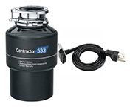
Tapware Faucet | Moen Kitchen Faucet | 1 - Moen Single-Handle Pre-Rinse Spring Pulldown Sprayer Kitchen Faucet with Power Clean in Chrome Color  21-9/10” Spout Height  Model# 5923 | Home Depot | 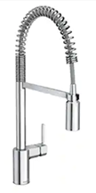
Cabinet Door Pulls | Hopewell Pull Handle | 17 - Hopewell Bar Pull  8 3/16” Long  Item: M1850  Polished Chrome | Top Knobs | 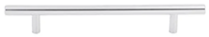
Cabinet Drawer Pulls Upper Glass Cabinets & Peninsula | Hopewell Pulled Handle | 11 - Hopewell Bar Pull  6 5/16” Long  Item: M1849  Polished Chrome | Top Knobs | 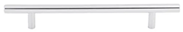
Appliances Dishwasher | Kitchen Aid Dishwasher | 1 Kitchen Aid  4 in. PrintShield Stainless Steel Top Control Built-In Tall Tub Dishwasher with Stainless Steel Tub, 44 dBA  Dimensions: H 33.63” x  W 23.88” x D 26.75”  Model# KDTM404KPS | Home Depot | 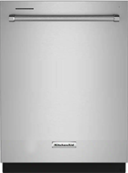
Appliances Trash Compactor | Kitchen Aid Trash Compactor | 1 - Kitchen 15” Built-In Trash Compactor in Stainless Steel  Dimensions: H 34.13: x W 15” x D 24”  Model# KTTS505ESS | Home Depot | 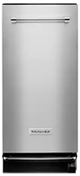
Appliances Refrigerator | Kitchen Aid Refrigerator | 1 - 27” cu. Ft. French Door Refrigerator in Print Shield Stainless with Exterior Ice & Water Dimensions: H 70.13” x W 35.69”,  D 36.63” Model# KRFF507HPS | Home Depot | 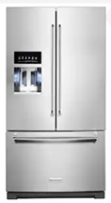
Appliances Microwave Drawer | Kitchen Aid Microwave Drawer | 1 - 1.2 cu. ft. Under Counter Microwave Drawer in Stainless Steel  Dimensions: H 16” x W 23.88” x D 23.25”  Model# KMBD104GSS | Home Depot | 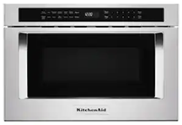
Appliances Electric Range Cooktop & Oven | Kitchen Aid Range with Oven & Cooktop | 1 - Kitchen Aid 6.4 cu. ft. Slide-In Electric Range with Self-Cleaning Convection Oven in Stainless Steel  Dimensions: H 36” x W 28.88” x D 28.88”  Model# KSEG700ESS | Home Depot | 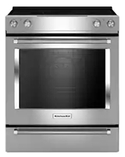

Pantry Schedule
ROOM | SURFACE | DETAILS, PROFILE, SIZE | SUPPLIER | SAMPLE
Pantry Wood Floating Shelves | Lumber: Common Board for Shelves | 12 - Wood Shelves, D 1”x W 12” x L 6 ft.  Model# 458503 | Home Depot | 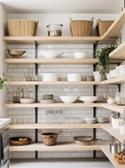
Black Steel Shelf Bracket | Black Steel Shelf Bracket for Wood Shelving | 24 - Crates & Pallet 12” Bracket  Model# 69104 | Home Depot | 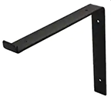
Pantry Bi-Fold Door & Hardware Kit | Calhome Bi-Fold Pantry Door | 1 - Panel Shaker Painted MDF Composite Bi-Fold Barn Door with Sliding Hardware Kit W 36” x  H 80” Sherwin Williams Paint Extra White SW 7006  Model# Bi-Fold, 1100-2-TOP+BF-1PANEL-36 | Home Depot | 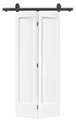
Bi-Fold Door Pulls | Hopewell Bifold Door Pull Handle | 2 Hopewell Bar Pull  6 5/16” Long  Item: M990Flat Black | Top Knobs
Pantry Wall Tile | Merola Tile for Walls | Metro Soho Subway  Glossy White  W 1-3/4” x L 7-3/4”  Model# FXLMSHSW | Home Depot | 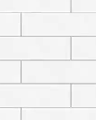
Pantry Wall Tile Grout | Polyblend Plus Grout for Tile | 1 - Color: Rolling Fog  25 lbs. bag  #544  Sanded Grout  688 sq ft. mix with water  Model# PBPG54425 | Home Depo | 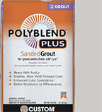

Living Room Schedule
ROOM | SURFACE | DETAILS, PROFILE, SIZE | SUPPLIER | SAMPLE
Electric Fireplace | Napoleon Ascent 40 Whisper-Quiet Built-In Electric Fireplace Insert | 1 - Item:03575914  NEFB40H  Plug in or Hardwired 120V/240V  LED Lights | Copperfield Chimney Supply | 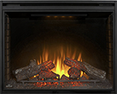
Fireplace Travertine Stone Tile | Claros Silver Split Face Free Length Travertine Fireplace Tile | River Rush  Item: 658966  4.31 sq ft per box  Textured  Natural Stone Tile  15% Overage recommended  Floor to 9’ Ceiling x 6’ Wide  = 54 sq. ft. | The Tile Shop | 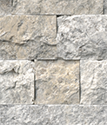
Fireplace Ledger Panel Option | Nepal | Silver Split - Face Marble Ledger Panel | Floor & Decor | 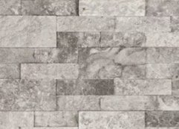
Wood Mantle on the stone fireplace | Modern Farmhouse Fireplace Mantel | 1 - Midnight Black Mantle  60” Length  9” Deep  5.5” Height  Solid Poplar Wood  Mounting Cleat & Hardware included | Dogberry Collections | 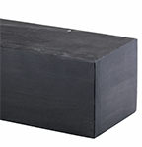
Television | LG | 1 – LG Smart TV | Amazon | 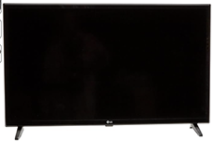

Laundry Schedule
ROOM | SURFACE | DETAILS, PROFILE, SIZE | SUPPLIER | SAMPLE
Storage Cabinet finish cupboards | Build floor to Ceiling Storage Cabinets | 1 - Storage Cabinet with Seat Bench, W 72” x D 12” x H 105”,  (4 ¼” Crown Molding)  3 – W 24” Cabinets,  6 – W 12” Doors,  3 Drawers W 24”  Sherwin Williams High Reflective White  SW 7757 | Stanley Wood Products | 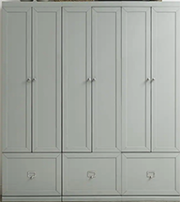
Storage Cabinet finish doors | Build Floor to Ceiling Shaker Style Doors | W 72” x D 12” x H 105”  (4 ¼” Crown Molding)  3 – W 24” Cabinets,  6 – W 12” Doors,  3 Drawers W 24”  Sherwin Williams High Reflective White  SW 7757 | Stanley Wood Products | 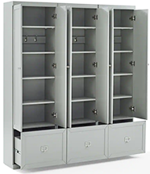
Wood Countertop N. Wall above Washer & Dryer | Wood Countertop, N. Wall above Washer & Dryer, from wall to wall | 1 - White Oak Blended Grain Butcher Block W 72” x D 24” x 1 ¼” Thick  Countertop  CT-BGWO | Hardwood Lumber Company | 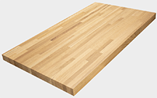
Right side of Washer & Dryer Floor Waste Pull-Out Cabinet | Custom Build Floor Waste Pull-Out Cabinet to right side of Washer & Dryer | 1 – Laundry Floor Waste Pull-Out Cabinet  W 19’ x H 34.5” x D 24”  Sherwin Williams High Reflective White  SW 7757 | Stanley Wood Products | 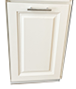
Washer & Dryer Set | Deco Washer & Dryer Set | 1 Set Washer/Dryer, Deco Pro3 Compact 110V Set Washer 1.6 cu. ft. + Dryer Vented 3.5 cu. ft Sensor/Refresh, White  Dimensions: H 65” x W 23.5” x D 22”.  (2” space between wall, washer, dryer, and cabinet total of 6” to move them in and out for repairs). | Home Depot | 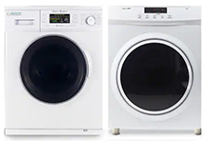
Dryer Exhaust Connection Kit | Snap to Vent Dryer Exhaust | 1 - Snap to Vent 4” Master Connector Kit for Dryer Installation Length Specifications: .4625 ft, width 4” | Home Depot | 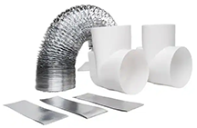
Cabinet Drawer Pulls | Hopewell Hardware Pulls | 2 - Hopewell Bar Pull 6 5/16” Long  Item: M1849  Polished Chrome | Top Knobs
Pocket Door | Kimberly Bay Solid Wood Pocket Door | 1 - 30” x 80” White 1-Panel Shaker Solid Core Wood Interior Door Slab, Thickness 1.375”, Sherwin Williams Paint Extra White SW 7006 Model# DPSHA1W30 | Home Depot | 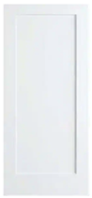
Pocket door lock | Prime-Line Pocket Door Lock | 1 - Prime-Line  Satin Nickel, Pocket Door Privacy Lock  Reversible design for left or right-handed doors  Used for doors 1-3/8” -to 1-3/4” thick  Model# N 7239 | Home Depot | 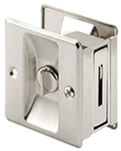
Pocket door hardware kit | Everbilt Pocket Door Hardware | 1 - Everbuilt Pocket Door Track & Hardware Set For use with doors up to H 80” x W 1-3/4” thick  Model# 12610 |  | 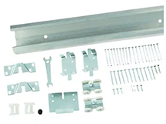

Water Closet Schedule
ROOM | SURFACE |  | DETAILS, PROFILE, SIZE | SUPPLIER | SAMPLE
Vanity Lower Cabinet Finish Cupboards | Vanity Cupboard |  | 1 – Three Post Grigg W 37" White Vanity  Sherwin Williams High Reflective White  SW 7757 | Wayfair  (Can be built by Stanley Wood Products) | 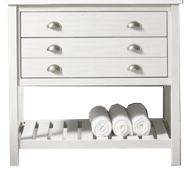
Vanity Lower Cabinet Finish Drawers | Vanity Drawers |  | 1 – Three Post Grigg W 37" White Vanity Drawers  Sherwin Williams High Reflective White  SW 7757 | Wayfair  (Can be built by Stanley Wood Products)
Wall Cabinet Over Toilet | Highland Dunes |  | 1 - Wayfair Highland Dunes Rysing Wall Mounted Cabinet, White, Dimensions:  H 24.5” x W 22.81”D 7.88” | Wayfair | 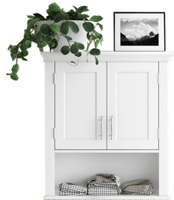
Cabinet Drawer Pulls | Amerock |  | 6 – Drawer Cup Pulls, Model: BP5301026 Dimensions: 3” Centers,  L 3 3/8” x W 1 ¾” x 1 ¼” Projection, Polished Chrome | MyKnobs.com | 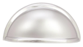
Cabinet Drawer Pulls |  | Hopewell Hardware Pulls | 2 - Hopewell Bar Pull 6 5/16” Long  Item: M1849  Polished Chrome | Top Knobs
Quartz Countertop & Backsplash | Calacatta Borghini,  Elements Quartz |  | Calacatta Borghini,  Elements Quartz,  Group 5  Backsplash is H 4” x L 30”  Countertop Vanity 30” W x 24” D | Central Surfaces, MO
Toilet | Swiss Madison Wall Hung Toilet |  | 1 - Ivy Wall Hung Elongated Toilet Bowl Only 0.8/1.28 GPF Dual Flush, Dimensions: H 13.37” x W 14.75” x D 20.68”  White, Model SM-WT450 | Home Depot | 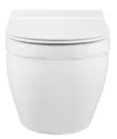
Sink | Kohler Rectangle Undermount Sink |  | 1 - Rectangle Undermount Bathroom Sink in White with Overflow Drain  L 19-13/16” x 15.625” | Home Depot | 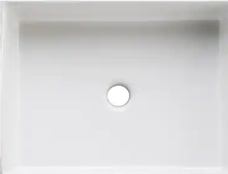
Sink tapware Facet | Vigo Water Faucet |  | 1 - Vigo Davidson 1.2 GPM Single Hole Bathroom Faucet  Model:VG01043CH  Polished Chrome  Spout H 4.375” | Home Depot | 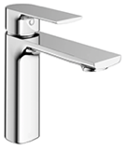
Sink Pop-Up Drain | Vigo Sink Pop-Up Drain |  | 1 - Vigo Vessel Bathroom Sink Pop-Up Drain and Mounting Ring in Polished Chrome  Model# VG16002CH | Home Depot | 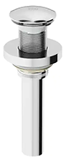
Round Vanity Mirror | Linden Round Vanity Mirror |  | 1 - 30” size  Finish Chrome  Mounting Cleat included | Pottery Barn | 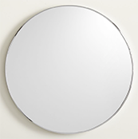
Pocket Door | Kimberly Bay Solid Wood Pocket Door |  | 1 - Panel Shaker Solid Core Wood Interior Door Slab, W 30” x H 80” x D 1.375”  Sherwin Williams Paint Extra White SW 7006 Model# DPSHA1W30 | Home Depot | 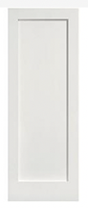
Pocket door lock | Prime-Line Pocket Door Lock |  | 1- Prime-Line  Satin Nickel, Pocket Door Privacy Lock  Reversible design for left or right-handed doors  Used for doors 1-3/8 “to 1-3/4” thick  Model# N 7239 | Home Depot
Pocket door hardware kit | Everbilt Pocket Door Hardware |  | 1- Everbuilt Pocket Door Track & Hardware Set For use with doors up to 80” high and 1-3/4” thick  Model# 12610
Towel Hook | Gatco Square Towel Holder |  | 1 - Gatco Square Form Towel Holder in Polished Chrome,  W 6.13” x H 7.13” x D 1.88”  Model: 5332 | Home Depot | 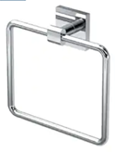
Toilet Paper Holder | Franklin Brass |  | 1 - Maxted Single Arm Toilet Paper Holder in Polished Chrome | Home Depot | 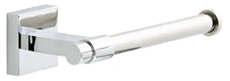
Grab Bar | Escutcheon |  | 1 - Bathroom Grab Bar 36” x 1 ¼” Product# 71844 | Harney Hardware | 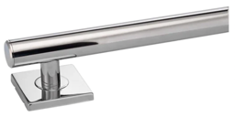

Mudroom Schedule
ROOM | SURFACE | DETAILS, PROFILE, SIZE | SUPPLIER | SAMPLE
Upper Bench Open Basket Storage, Lower Bench Seat with Open Basket Storage Below | Custom Storage Bench | 1 - Custom Mudroom Bench Storage  W 4’, D 1’ Above Bench Seat.  W 4’, D 2’ Below Bench Seat.  H 86” (Seat is about 18” up from the floor)  White Oak Bench Seat Natural, and the rest is painted Sherwin Williams High Reflective White SW 7757 | Stanley Wood Products | 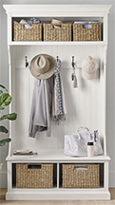
Coat/Hat Hooks | Bench Hooks | 4 - Liberty  Ruavista 4.38 in. Flat Black Coat and Hat Hook Dimensions: H 4.37” x W 2.89” x D 1.85  Model# B21845Z-FB-CP | Home Depot | 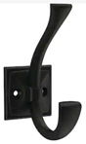

TV/Game/Study Schedule
ROOM | SURFACE | DETAILS, PROFILE, SIZE | SUPPLIER | SAMPLE
TV/Game East Wall, Vertical Slats on a TV Feature Wall | E-Joy Oak Wall Paneling | 2 pkg - E-Joy Wall Paneling 8 pkg. W 6” x L 106” Light Oak,  W 72” Soundproof, Glue Down, Engineered Wood | Wayfair | 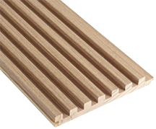
Wood Mantle on the Wood Panels | Modern Farmhouse Fireplace Mantel | 1 - Midnight Black Mantle  60” Length  9” Deep  5.5” Height  Solid Poplar Wood  Mounting Cleat & Hardware included | Dogberry Collections
Black Metal Grill Bi-Pass Door with Hardware Kit | Jubest Glass By-Pass Door with Black Grill | 1 - Glass Bypass Barn Door with Installation Hardware W 60” x L 84”, Black Grill | Wayfair | 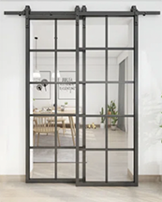

Lighting & Fan Schedule
ROOM & TYPE | SURFACE | SIZE/COLOR/FINISH | BULB DETAILS (QTY) | SUPPLIER | IMAGE
Exterior Front & Back Entry Wall Sconces | Millhouse Exterior Sconces | 4 - Millhouse Outdoor Sconce, Outdoor, Small, Black  Dimensions: H15.5" x W 7"x D 7.5"  SKU OL18073 BK | 4, 100-Watt E26 Bulb | Shades of Light | 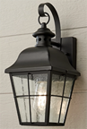
Exterior Front & Exterior Back Flood Lights | Generation Lighting Exterior Floor Lights | 6 - Flood Light 120-Watt Black Outdoor Adjustable Swivel Flood Light, Black  Dimensions: H 12.25” x W 5.6875” x D 9.25” | 120-Watt BR40 medium base light bulb, 6 needed | Home Depot | 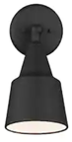
Peninsula Pendants | Bentlee Pendants | 3 - Carillon Pendants, Small, Black, Dimensions: H 14.5” x W 14.25 x D 25”, SKU PE19019 BK | 3, E 26 Bulb, 75 Watt | Shades of Light | 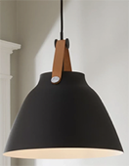
Water Closet Multi-Bar Light | Truncated Cone Shade Vanity Lights | 1 - Truncated Cone Shade Vanity Lights 3 in Bar, Polished Chrome  Dimensions: H10” x W 27.25" x D 8.5"  SKU BS18071 CH | 3 LED clear bulbs | Shades of Light | 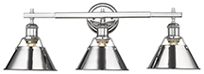
Water Closet Exhaust Fan | Panasonic Water Closet Exhaust Fan | 1 - Panasonic WhisperFit DC, Pick-A-Flor, 50, 80, 110, CFM Energy Star Quiet Ceiling Bathroom Exhaust Fan w/Flex-Z Fast Install Bracket 1 White, Measures L 13” x W 13” x H 6.5”  Model# FV-0511VF1 | No Bulbs | Home Depot | 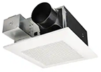
Living Room Ceiling Fan/Light | Progress Lighting Ceiling Fan/Light | 1 - Glenfalls 56" Indoor Ceiling Fan with LED Light Kit and Remote Control, Blade Span W 56" x H 14-7/8" Model: P250021-028-30, Satin White, Dimmable | LED Light, 24 Wattage, Lumens 2100 | Build With Ferguson | 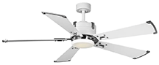
Kitchen Insert Range Hood, Exhaust & Light | Zepher Monsoon I, Exhaust Fan/Light | 1 - Zephyr Monsoon I  36” Insert Range Hood with Fan/Light in Stainless Steel  Model# AK9234BS  Dimensions: H 12”, x W 34.38” x D 0 in | LumiLight LED Lighting | Home Depot | 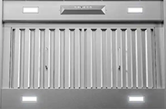
1 Water Closet  4 Kitchen  4 Living  2 Dining  1 Pantry  1 Mudroom  2 Laundry  3 TV/Game/Study  6 Central Hallway  2 Stairway  (26 total) | Nuwatt LED Canless Recessed Downlight | 26 - White NUWATT White 5” or 6” diameter, D 5”.  1000-Lumen Switchable Round Dimmable LED Canless Recessed Downlight (24-Pack)  Item #4911052  Model #NW-R-DSK-6-15W30K24P | LED 15 watt | Lowe’s | 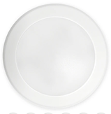
Recessed Eyeball Light | Progress Lighting | 1 - Progress Lighting 6 in. PAR30 Satin White Eyeball Trim Round Recessed Light for 6 in. Housing, 1 Pack,  Dimensions: H 4” x W 7.75” x D 7.75” | 1 Integrated LED Lighting | Home Depot | 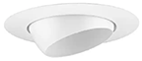
Kitchen LED Strips under cabinet to light countertop & in the top glass cabinets on both sides of the Range | Wac LED Lighting Strips | InvisiLED Lite, 24V, AC/DC, LED Tape Light, 3000 Kelvin is the Temp. Color  Diodes spaced at 1” on center, 1/8” profile  LED-T2430L-1-WT,  0.08A | LED Strips | Rensen House of Lighting | 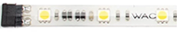
Kitchen LED Power Supply | Wac Lighting Power Supply | 1 - InvisiLED, 24V, 60Watt, Class 2, Plug-In Power Supply (30’ needed for each Driver) | None | Rensen House of Lighting | 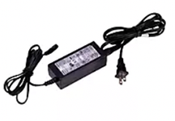
LED Strip Light Extension Cable to Bridge Across Range | Wac Lighting Extension Cable | 1 - InvisiLED, 24V Extension Cable | None | Rensen House of Lighting | 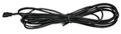
Return Air Grill | Everbilt Return Air Grill | 4 - Everbilt  1-Way Steel Baseboard Return Air Grille, White, W 12” x H 6” | None | Home Depot | 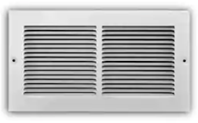
Floor Register Vent | Homewell Oak Floor Register | 8 - Homewell White Oak Wood Floor Register Vent, Flush Mount with Frame, Vent W 4” x L 10”, Exterior of Frame L 12.25” x W 6.75” x H 0.75, Unfinished | None | Amazon | 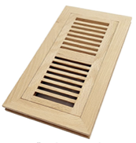

Front/Back Door & Window Schedule
ROOM | SURFACE | SIZE/COLOR/FINISH | SUPPLIER | IMAGE
Front & Back Door | Jeld-Wen Exterior Front & Back Doors | 2 - Jeld-Wen W 30” x H 80”, 3 Lite Craftsman Black Painted Steel Pre-Hung Left-Hand Inswing Front Door w/Brickmould  H 81.75 x W 31.438” x  D 1.75” | Home Depot | 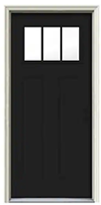
Front & Back Hardware | Artemis Mortise Lock for Front & Back Doors | 2 - Artemis Mortise Lock, Polished Chrome (US26), Laurent Knob (LAU), Deadbolt, 2-1/2" or 2-3/4" Backsets | Emtek | 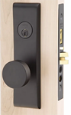
Option 1: Wood Casement Windows | Jeld-Wen Casement Windows 28” Wide  (They do not make picture windows in this size so changed to Casement for all) | 10 - W 28” x H 48”,  W-2500 Series Black Painted Clad Wood Left-Handed Casement Window with Colonial Grids/Grilles, Dimensions: H 48” x W 28” x D 4.563” | Home Depot | 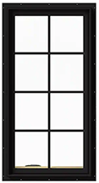
Option 1: Wood Casement Windows | Jeld-Wen Casement Windows 24” Wide (They do not make picture windows in this size so changed to Casement for all) | 2 - W 24” x H 48”, W-2500 Series Black Painted Clad Wood Left-Handed Casement Window with Colonial  Model# THDJW140100368  Grids/Grilles, Dimensions: H 48” x W 24” x D 4.563” | Home Depot | 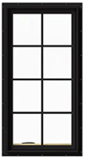
Option 2 Steel Casement Window | Black Badge Doors & Casement Windows 32” Wide | 6 - Single Casement Steel Metal Window, Black, 32” W x 72” H, 2 pane Tempered Glass filled Argon Gas | Black Badge | 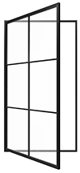
Option 2 Steel Casement Window | Black Badge Doors & Casement Windows 24” Wide | 2 - Single Casement Steel Metal Window, Black, 24” W x 72 x H,  2-pane Tempered Glass filled Argon Gas, Flank Fireplace | Black Badge
Option 2 Steel Picture Window | Rectangle Steel Metal Picture Window 32” Wide | 4 - Single Rectangle Steel Metal Picture Window, Black, 32” W x 72” H, 2-pane Tempered Glass filled Argon Gas | Black Badge | 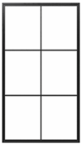

Stair Schedule
ROOM | SURFACE | SIZE/COLOR/FINISH | SUPPLIER | IMAGE
Balusters | Iron Baluster 9000 | 40 - Iron Balusters  ½” Square, Plain,  Satin Black  (3 per step except on the ones with a Newel and then it uses 2) | JMP Wood | 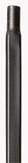
Base Shoe w/Screw | Base Baluster Shoe 9062BS | 40 - Baluster Shoe 9062BS, ½” Square, Base Shoe w/Screw, Satin Black  (3 per step except on the ones with a Newel and then it uses 2) | JMP Wood | 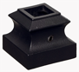
Bracket | Handrail Bracket | 2 - Handrail Brackets 3000 Square, Satin Black | JMP Wood | 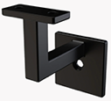
Handrail | Handrail | 2 - White Oak Handrail 6225, 2 ¼” wide, 1 5/8” height, over 8’ LTL freight shipping | JMP Wood | 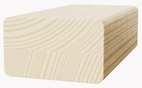
Newel Post | Box Newel, Mission Style | 4 - White Oak, Box Newel 4375M, Mission Style, 4 - 3/4” | JPM Wood | 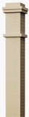
Wood Tread & Riser | Retro Tread – Straight Ends w/Riser | 8 - Retro Tread – Straight Ends w/Riser, White Oak, 9’ Ceiling Height, 48” wide  8” Rise x 11” Tread | JMP Wood | 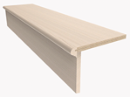

Entry Hall
ROOM | SURFACE | SIZE/COLOR/FINISH | SUPPLIER | IMAGE
Custom Built Console Table | Custom Build Console (Option to find one to paint the correct color) | 1 - W 48” x D 12” x H 31” Build a console table. Can be deeper if needed. (2 sets of doors, no center drawers). Paint with Sherwin Williams Aleutian SW 6241, Semi-Gloss | Stanley Wood Products

Interior Design by Holland
16304 Wedd Street, Overland Park, KS 66085
flatlandholland@yahoo.com
(785) 550-0175

